**COS60010**

**Technology Inquiry Project**

**Semester 1 - 2024**

**Deliverable 4**

**Individual Project Report**

**Student Name:** Arun Ragavendhar Arunachalam Palaniyappan

**Student ID**: 104837257

**Facilitator:** Dr. Alfandi Yahya

**Workshop:** Thursday – 14:30-16:30 - Room EN207

Contents

1. Introduction 5

2. Contributions 6

2.1 Project Motive: 6

2.2 Individual Research: 6

2.3 Design Contributions: 7

2.3.1 Database Design 7

2.3.2 Entity-Relation Diagram 8

2.3.3 Backend system Design of the Results page 8

2.3.4 Front end System Design of the Results page 9

2.3.5 Evidence for the Design Work contributions: 10

2.4 Code Contributions: 12

2.4.1 Coding Overview 13

2.4.2 Evidence of coding work done: 14

2.4.3 Part By part Code explanation with Code Snippets 14

2.4.4 Display of Final Results and Student Feedback 24

2.4.5 Leaderboard, game statistics and viewing peer performance 25

2.5 Team Contributions: 25

2.5.1 Team Engagement and Communication 25

2.5.2 Taking Leadership of Team Activities 27

2.5.3 Technical Support and Collaboration 28

3.Learning outcome Reflection 29

3.1 Role of programming fundamentals to identify and solve problems at various situations. 29

3.2 Reflection on using self and peer evaluation to enhance the individual work done. 29

3.3Application of advanced programming fundamentals to solve complex technology challenges in the project to overcome steep hurdles. 30

3.4 Usage of project management tools to effectively aid team collaboration. 30

3.5 Evaluation of information obtained from research on new technology and application of the new learnings in the project. 31

3.6 Influence of Cultural and Social perspective on the learnings, Individual work done and the outcome of the project. 31

5.Summary 32

6.Appendix 33

6.1 Abbreviations 33

6.1 List of figures and tables: 33

7. References 34

Overall word count (excluding title page, table of contents , captions, : **3817**

Acknowledgement to country,

appendix and references)

**Acknowledgement to Country**

What was formerly the Kulin Nation is now home to Swinburne University of Technology and Melbourne, Australia. I, as a Swinburne student, who is really appreciative and happy to be enrolled in this prestigious school, would want to respectfully offer my sincere condolences to the Wurundjeri People of this country, who are the original occupants of these territories.

Furthermore, I extend our heartfelt gratitude to Swinburne's Aboriginal and Torres Strait Islander students, alumni, partners, and visitors.

I am honoured and happy to appreciate the connection between this location's spirituality, history, and culture, and the Wurundjeri land.

# 1. Introduction

The main goal of the Technology Inquiry Group Project was to build an interactive Chemistry Quiz application – **“Chem Quiz”** for the client **Instatute Learning Pty.Ltd,** based on their main requirement of gamification as a tool for increasing interactions and improving student engagement in their teaching, for high school students preparing for university entrance examinations.

In a period of 12 weeks, the User requirements were gathered and the project was designed, developed, tested, and delivered successfully.

On the whole, **“Chem Quiz”** is a web-based game-like Quiz application where students play a chemistry-based quiz where they answer chemical structures and reaction-based questions like an interactive game and are instantly shown their results. Once a student finishes a game attempt, they are also shown a web forum like Player statistics leaderboard where they can see and get to know their peer performances and can analyse were they stand.

The **“Chem Quiz”** application has been developed and made available as a support tool within the main website of Instatute. Every registered student can have a Username and Password and can Login and play the quiz. A staff admin can also login and can add, delete and modify the chemistry questions as well as student records.

The application uses a **MySQL** database to store, retrieve and handle user data, **HTML** and **CSS** for client-side web page display**, JavaScript** for client-side rendering of the questions and student interactions and **PHP** for server-side processing of the results as well as the user and game related statistics.

The main purpose of this document is to report and discuss in detail about the **individual contributions** in the design, development and delivery of this Group Project “Chem Quiz”.

The main Individual contributions are:

* System Design and development of the **Users table** and **Scores table** in the Database (MySQL).
* System Design and Development of the **Results page** with its server side (PHP) and client-side functionalities (JavaScript) and styling and design of the UI(CSS).
* Technical Inputs and suggestions to other team members on the design and development for all pages and all functionalities of the application.
* Team management – booking rooms, scheduling and co-ordinating team meetings and discussions.
* Technical Documentation work for the project concept report (Deliverable 2) and project final delivery (Deliverable 3).

The report contains week by week progress updates, Trello boards describing the tasks that were done, evidences and screenshots for the work done, such as code snippets, mails, group chats and version control updates in GitHub.

# 2. Contributions

## 2.1 Project Motive:

After discussing thoroughly about their specific application requirements with Instatute Learning Pty.Ltd, it was decided to build an interactive chemical structure and reactions-based Chem Quiz application for their students. The first individual contribution was to conduct full-fledged Individual research, to fill the knowledge gaps in order to proceed with the design and development of this full stack application.

## 2.2 Individual Research:

After conducting an extensive Individual study, the following decisions were taken:

* Even though **Instatute Learning Pty.Ltd** were preferring a Python based project, the final team decision was to use the below technology stack instead of python.
* **HTML, CSS –** to display the webpages and style the User Interface.
* **JAVASCRIPT –** to make the website interactive and render the details on the webpage
* **PHP –** to connect to the database and to calculate Student scores and game statistics.
* **MYSQL database –** to store, retrieve and maintain user data.
* These technologies were chosen as “Chem Quiz” is a web-based application and the above technology stacks are best suited for web application development when compared to python. **(Full,2020).**
* There was no necessity to use python for the requirements of this project.
* Moreover, this **project could not be done in python** **because**, this application requires the drawing of chemical structures and reactions. The library that supports this drawing tool, namely **JSME kit** and **RD kit** is supported only in JavaScript. Python does not have a similar library as of now. **(Landrum,2013).**
* Hence, the syntax, fundamental concepts, working logics, declarations, methods, functions, program execution control flows of the above-mentioned technology stacks, were studied and practised to lay a strong programming foundation to execute the project.

## 2.3 Design Contributions:

### 2.3.1 Database Design

The design phase was carried out from **week 2 to week 6.**

In this time period, all learnings from the Individual research were put into implementation to convert the user requirements to an executable system design.

A **‘Chem quiz’** database was first designed and created for storing and manipulating project related data.

* A **Users** table was created to store user related data.
* A user can login to the Chem Quiz application using a username and password. Users can either be a student or an admin.
* The Users table has an ‘**userId**’ attribute which is a Primary Key to Uniquely identify every user.
* The user password is hashed in PHP and the hashed password is stored in the table for enhanced security and privacy.
* **‘isAdmin’** attribute is used to check if the user is a player or an admin using Boolean values. The **‘isAdmin’** value is ‘1’ for an admin and ‘0’ for a student.

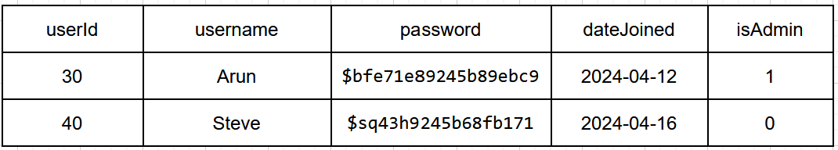

Table 1: Relational DB schema with sample record of Users table.

Once a student finishes a game attempt, his /her score is calculated in the backend using PHP and that score and attempt details are updated and stored in the database.

Hence, a **Scores** table was designed and created for this activity in the database.

* The Scores table has a ‘**gameId**’ attribute which is a Primary Key to Uniquely identify every game attempt of every user.
* It has a ‘**score’** attributeto store the score of that particular game attempt.
* It also has an **‘attemptDate’** attribute to store the date on which that particular attempt was made.

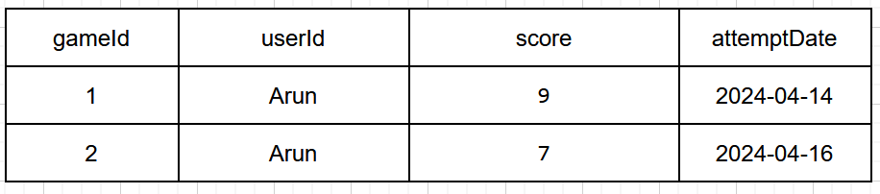

Table 2: Relational DB schema with sample record of Scores table.

### 2.3.2 Entity-Relation Diagram

* **‘Scores’** table is a child of the Users Table (1: n relation) and references it through the foreign key ‘userId’. **(Delisle, 2006).**

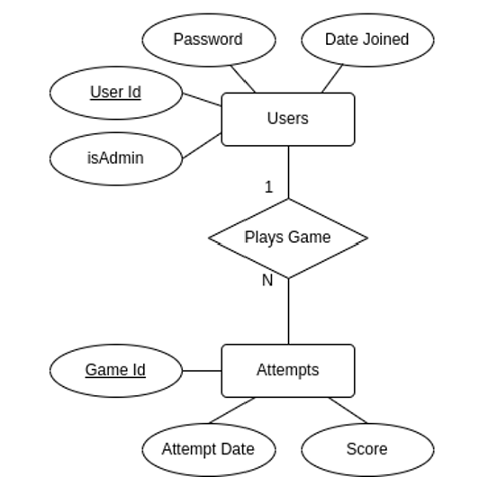

Fig1: Entity-Relation Diagram of Users and Scores Table

### 2.3.3 Backend system Design of the Results page

* The main application functionality is that, a student can play a quiz, where he/she answers a set of questions and once they submit the answer for the final question, he /she is given the result and game statistics instantly.
* **PHP** has been used on the server side because it provides more flexibility than any server-side language for web development and can be customised easily

**(Nixon, 2021).**

* In order to calculate the results, the following steps were designed:
* The IDs of the questions, the student’s answer and the userId are sent to the backend.
* A **PHP** file in the backend, queries the database for the actual correct answer for the given set of questions.
* If the actual correct answer matches the student answer for a specific question, the student score is incremented. After checking the same for all the questions, the final student score is calculated.
* Student score and current attempt details are then updated in the **Scores** table.
* Next, the **PHP** file queries the database to fetch the game statistics data in order to display it to the student, when he /she returns back to the Welcome page.
* This data includes:
  + Total number of Quiz attempts of the student.
  + Score details of the student’s last 5 attempts based on date of attempt.
  + A student leaderboard which shows the top 5 students in the quiz along with their individual High scores.

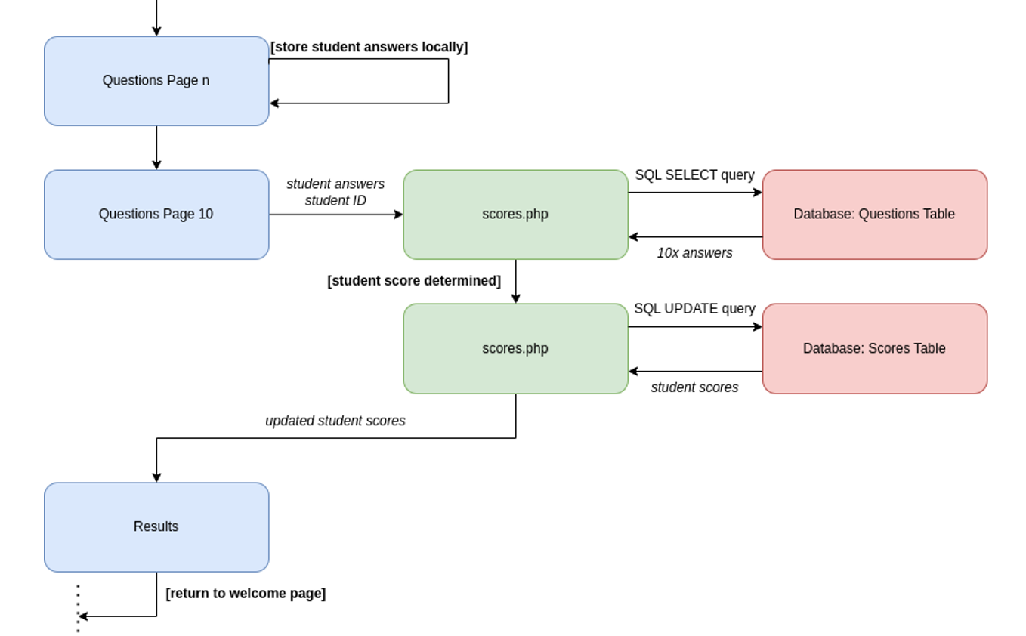 **Fig.2: Control flow of the system for the results page**

### 2.3.4 Front end System Design of the Results page

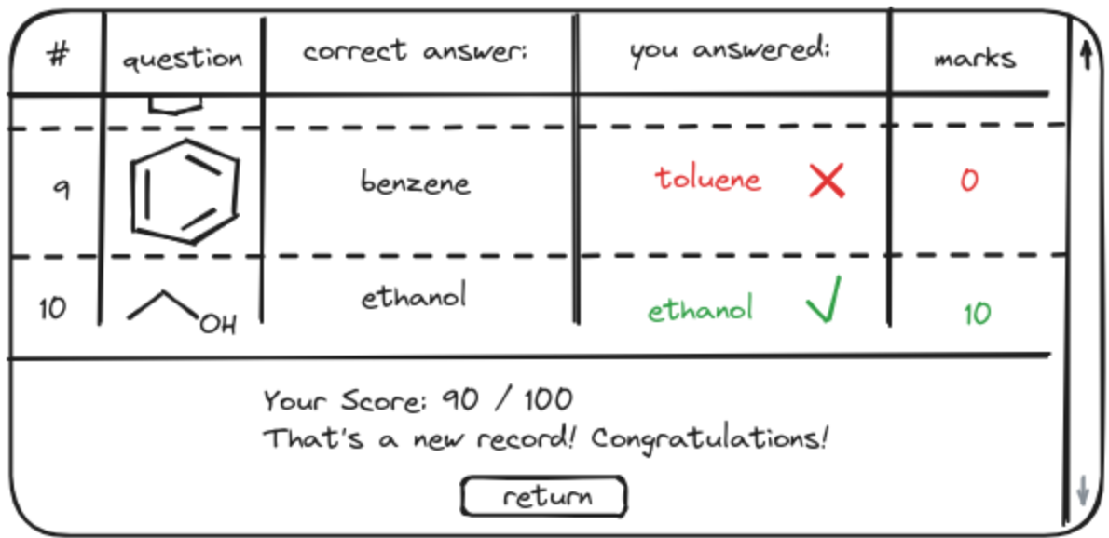

Fig.3: A Sample sketch for the results page User Interface

Once the student results and the game statistics have been calculated and updated on the server side, the data is transferred back to the client side to be rendered and displayed to the user.

**Steps of Implementation:**

* A **JavaScript** file fetches and collects the data from the backend **PHP** file.
* The **JavaScript** file uses a set of functions to render the questions, the student’s answer and the actual correct answer one by one, for all the 10 questions.It then renders the score of the user and displays a unique message to the student based on the score attained. **(Simpson, 2023).**
* A **HTML** file displays all these details to the user on the browser window.
* A **CSS** file has also been created to style the html page, to provide an accessible, neat and clean User Interface to the person viewing it.
* On Pressing the button **‘Return’**, the student is directed back to the welcome page, where the updated game statistics that have been calculated and updated are displayed.

### 2.3.5 Evidence for the Design Work contributions:

Individual System Design architecture was uploaded to the files section in canvas

on **April 10, 2024 (end of week 6).**



Fig.4: Evidence Screenshot-1 for System design Contributions

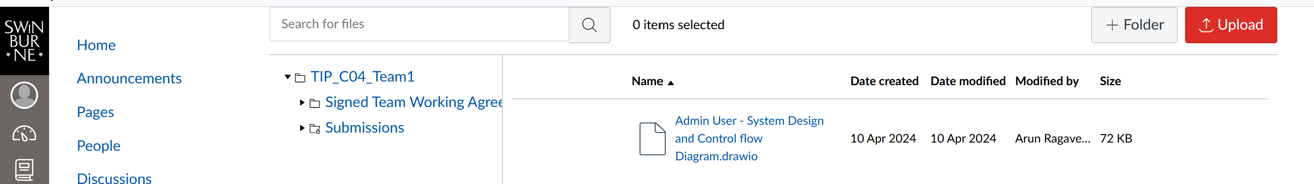

Fig.5: Evidence Screenshot-2 for System design Contributions

Concept report containing the Individual design structure was mailed to team member

on **April 10,2024.**

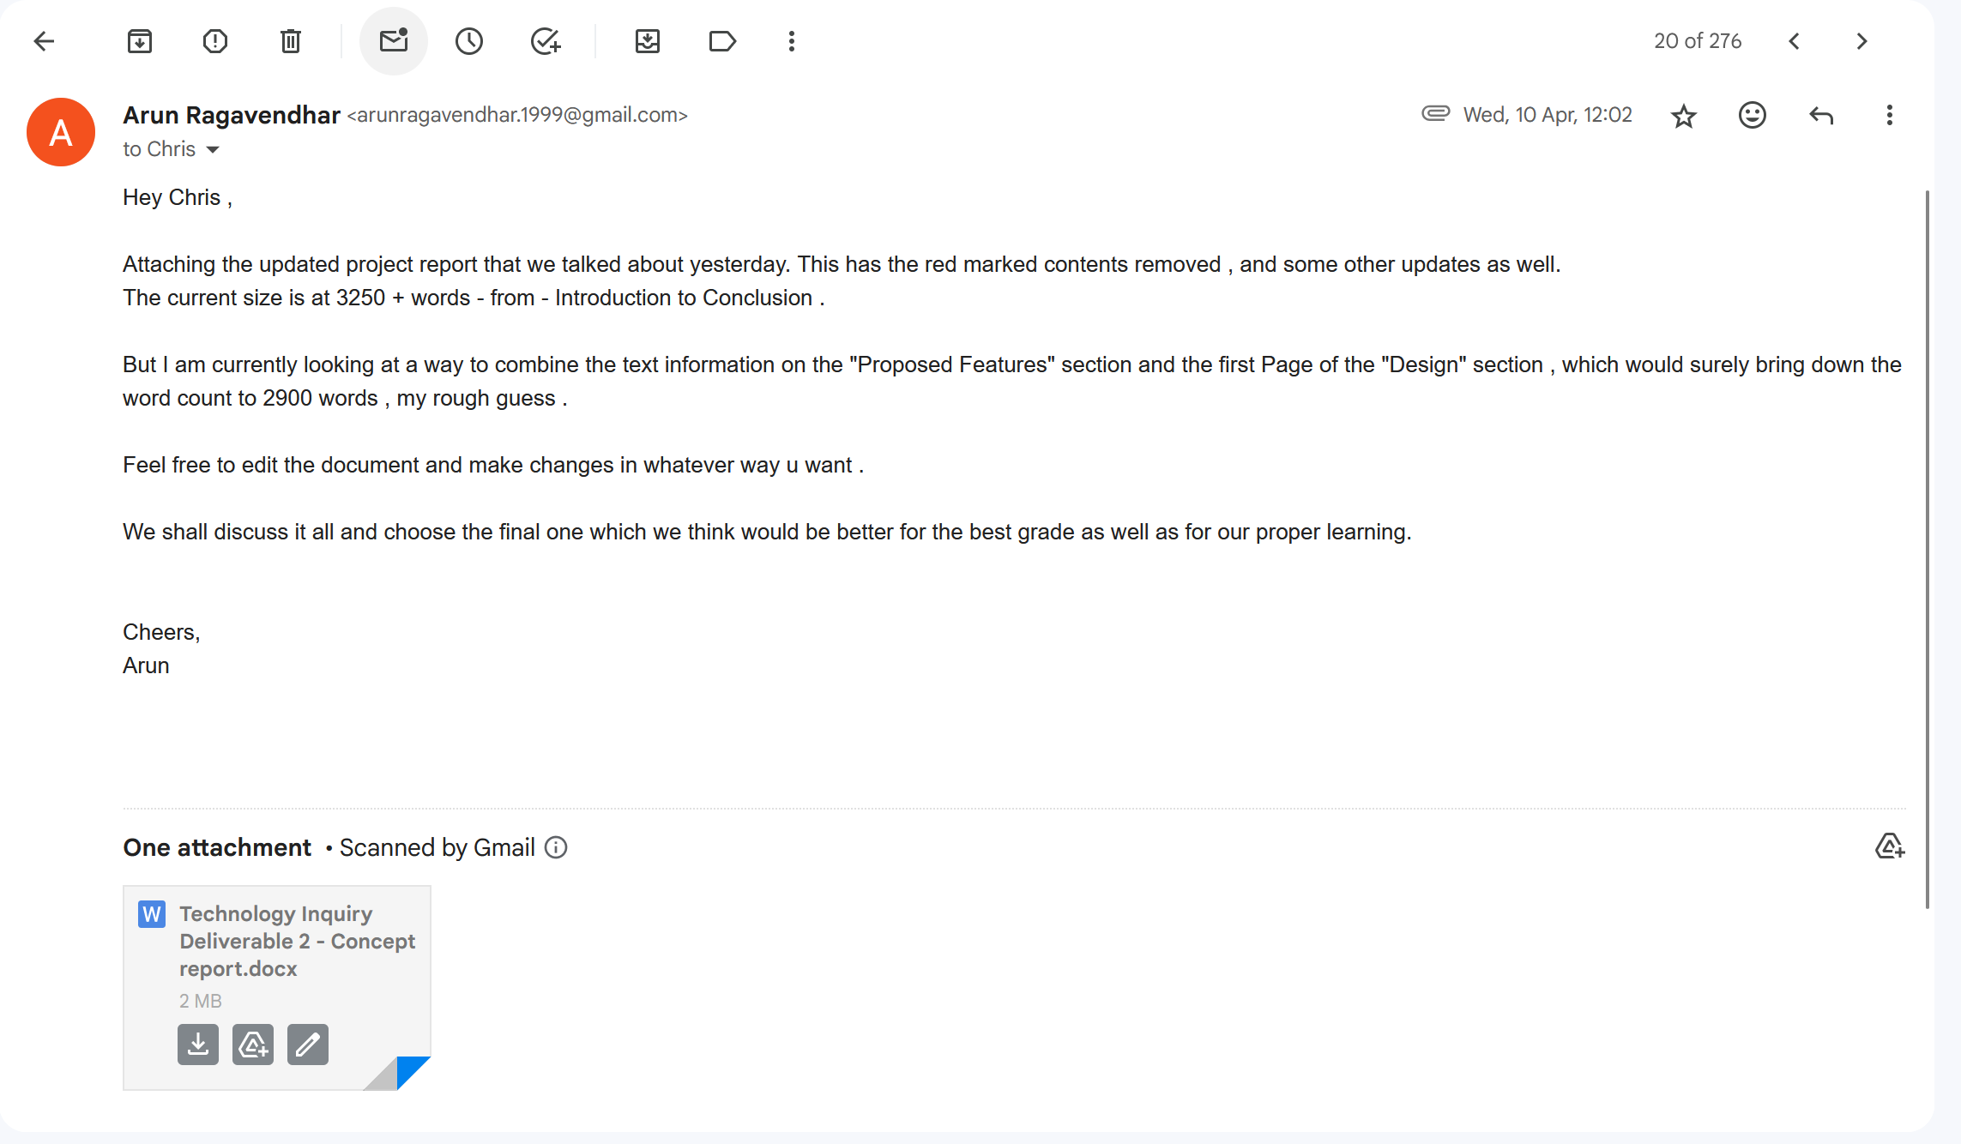

Fig.6: Evidence Screenshot-3 for System design Contributions

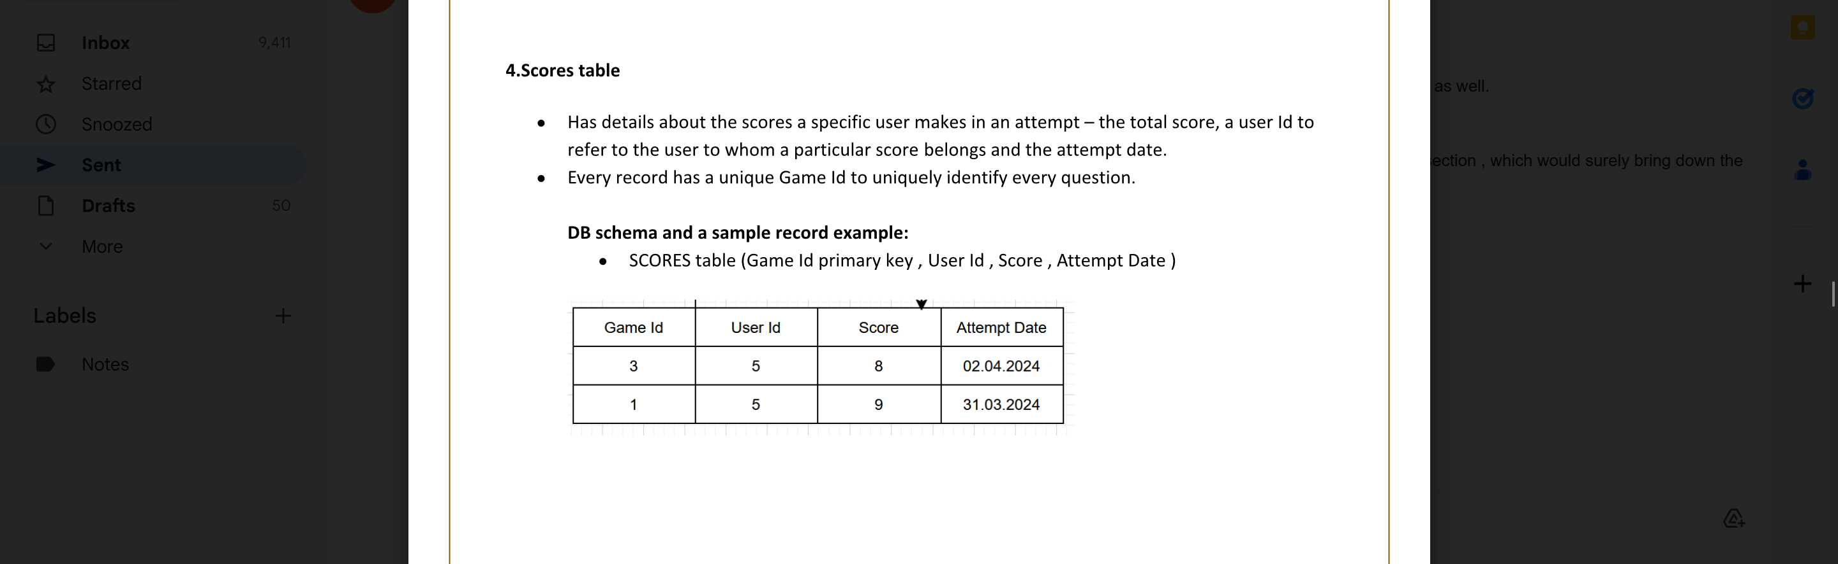

Fig.7: Evidence Screenshot-4 for System design Contributions

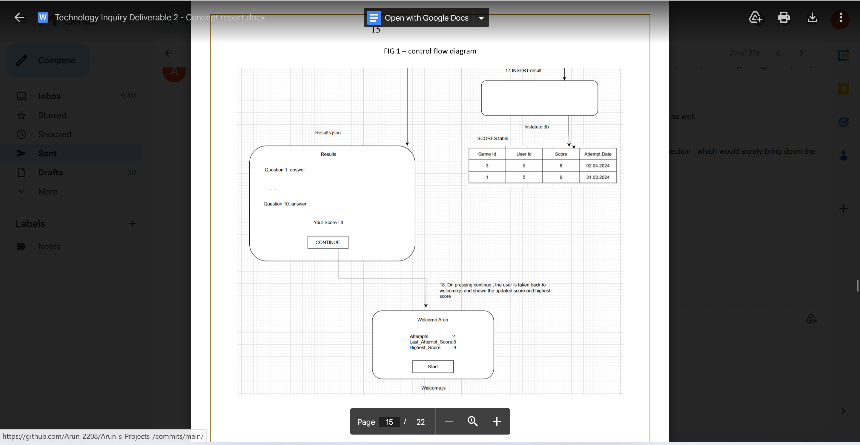

Fig.8: Evidence Screenshot-5 for System design Contributions

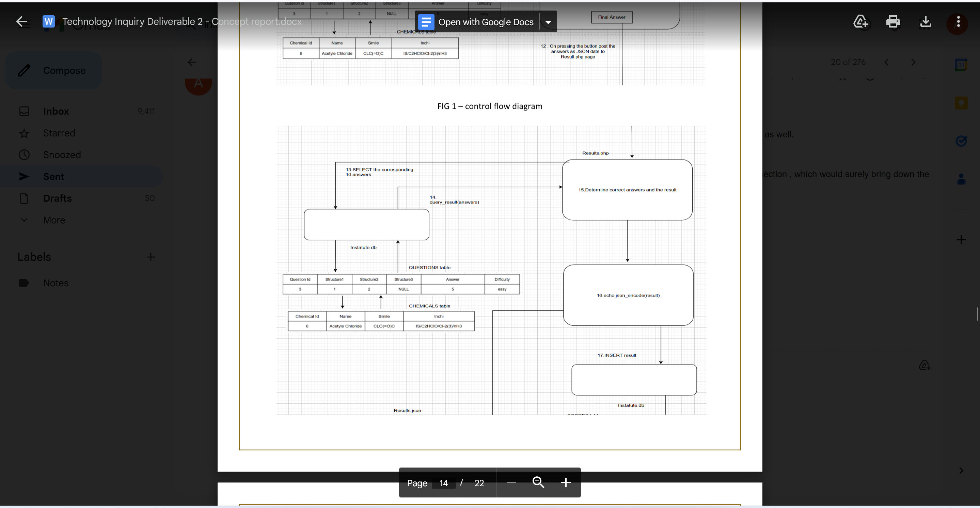

Fig.9: Evidence Screenshot-6 for System design Contributions

## 2.4 Code Contributions:

Once the System design was finalized, a Ghantt chart and Trello board was put up to

to split the individual work into schedules and sprints.

The project was planned to be executed in 2 sprints for programming

* Sprint 1 – Week 6 to Week 8
* Sprint 2 – Week 9 to Week 11

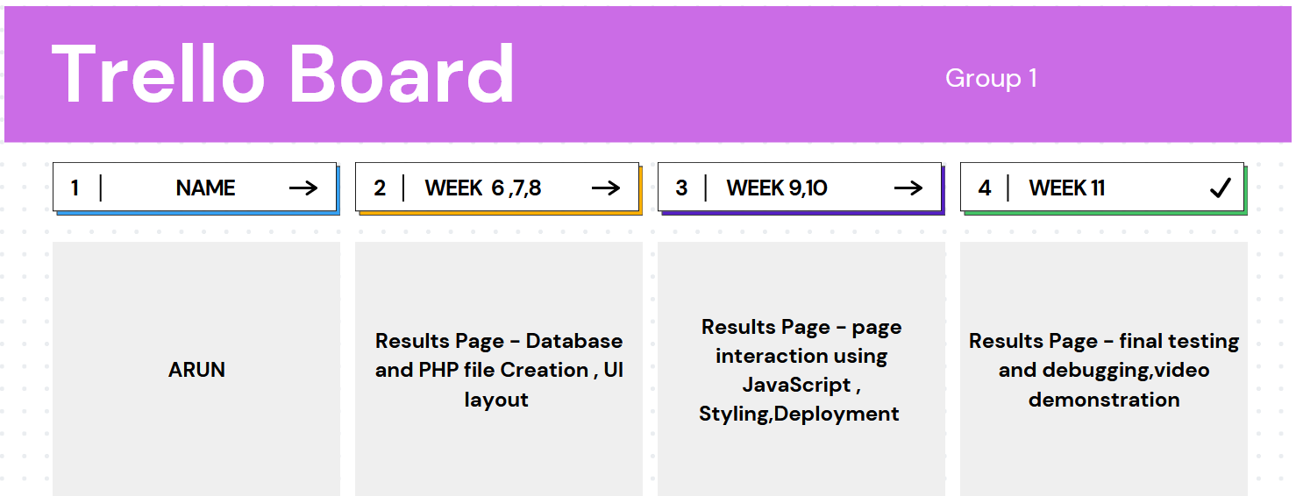

Fig.10: Trello Board listing out the Individual Tasks

The below Ghantt chart lists out the weekly Individual tasks done for the design, testing, development and delivery of -

* Database tables
* PHP, JavaScript, HTML and CSS files for Results page and User’s Game statistics data.

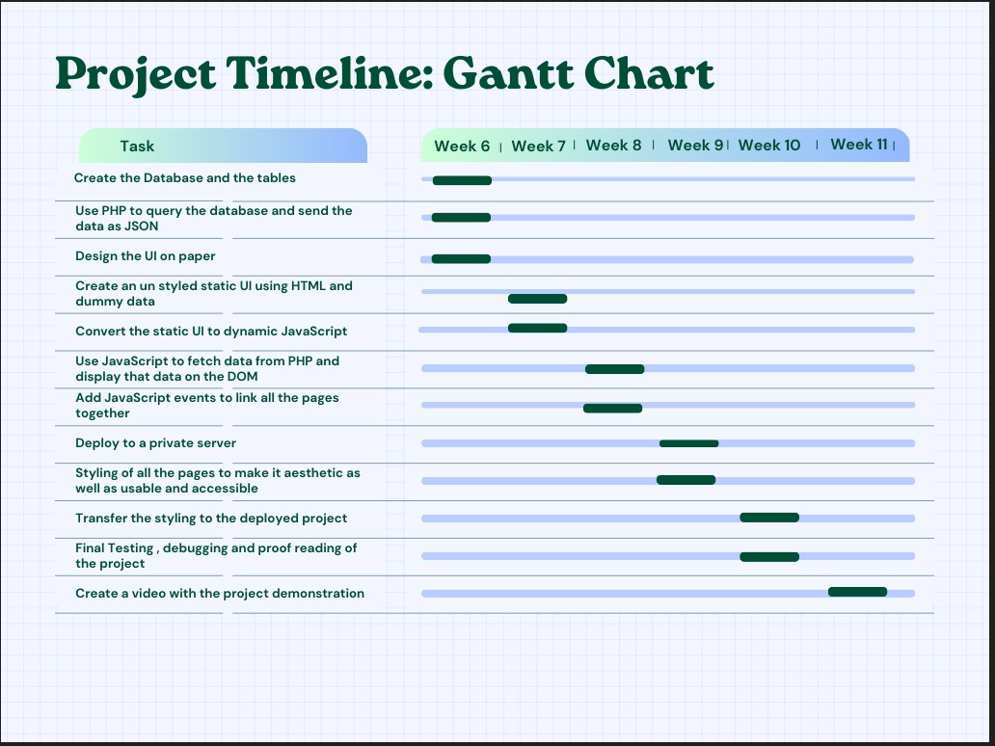

Fig.11: Ghantt Chart listing out the step by step weekly Individual Tasks

### 2.4.1 Coding Overview

The individual coding work that has been implemented:

* Tables to store user data, user scores and game related data were created.
* The Questions presented, their question Id, student’s answer and their userId were fetched from the Questions page.
* Then, the actual correct answers were fetched from the database for it.
* The user score was calculated.
* The User score and game related data were updated in the Scores table when the database was queried to calculate and update game statistics of the user.

The week-by-week coding work that was done along with the explanation of the code has been provided below. The evidence for the work has been provided through:

* GitHub version control updates which show the commits and updates that have been done and the complete source code link.
* Code snippet that was coded and side by side explanation of how it works.
* Complete source code which has been attached in a zip folder submitted along with this report.

### 2.4.2 Evidence of coding work done:

**GitHub Link for Version Control history:**

[https://github.com/Arun-2208/Arun-s-Projects-/commits/main/](%20https://github.com/Arun-2208/Arun-s-Projects-/commits/main/)

**GitHub Repository Link to view the complete source code of Individual Work:**

<https://github.com/Arun-2208/Arun-s-Projects->

### 2.4.3 Part By part Code explanation with Code Snippets

### 

* **A ‘CREATE TABLE’** SQL query was used to create the Scores and Users Table.
* **A ‘INSERT’** query used to write some sample records in the database to test them.

**(Gehani, 2011).**

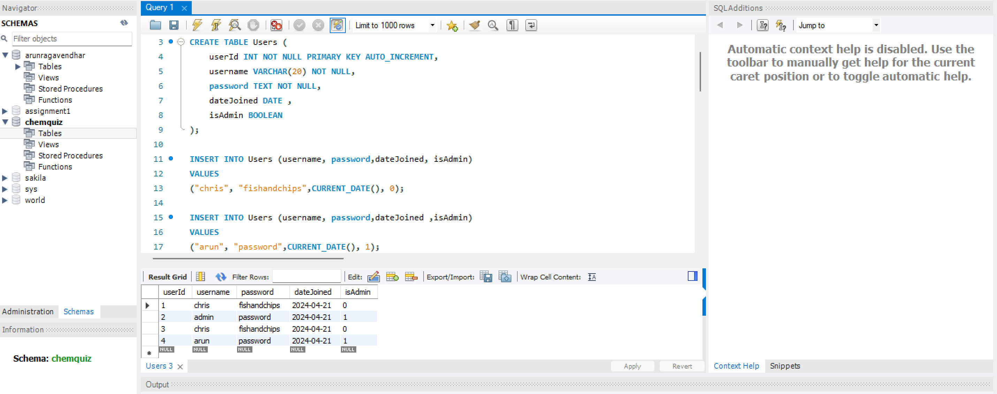

**Fig.12: Evidence Screenshot 1- for tables creation**

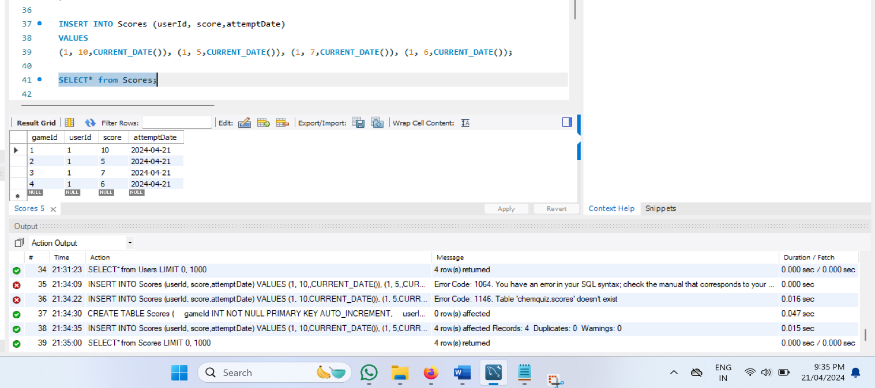

**Fig.13: Evidence Screenshot 2- for tables creation**

* A **settings.php** file was created to connect and interact with the database.
* It uses the host address, username, password and database name to make the connection to the database.

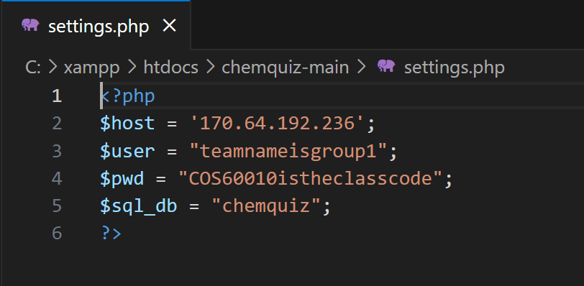

**Fig.14: Code snippet 1– Data base connection setup**

* A **results.php** file was created, which references the **settings.php** file to connect to the database with a **mysqli_connect** statement.

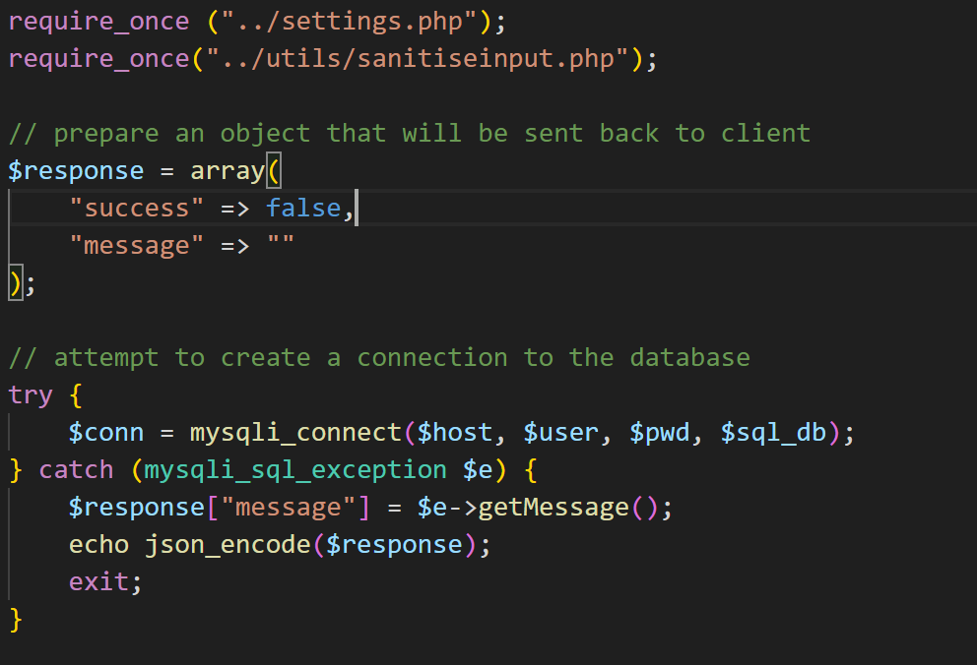

**Fig.15: Code snippet 2 – Data base connection query**

**Getting the Player Answers from Questions .js file**

* Once the student submits the final answer, the **results.php** file gets the player answer, the question Id and the question type for each question from the questions. js file as JSON encoded data.
* The **results.php** file decodes this JSON data stream and now has the questions as an array of objects.

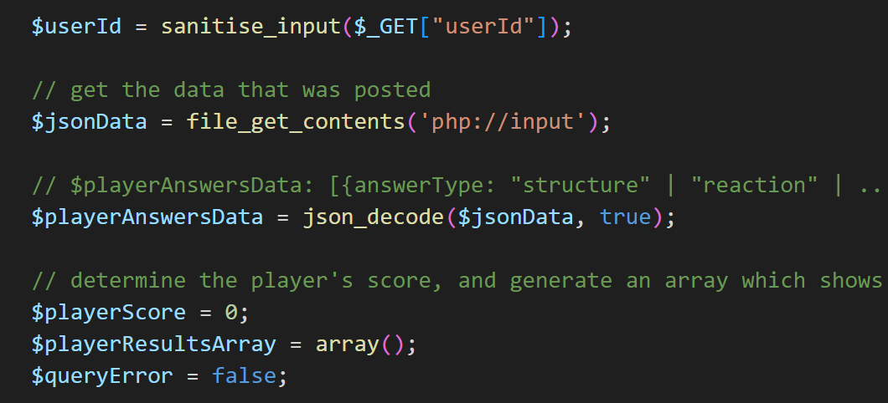

**Fig.16: Code snippet – getting the player answers**

**Input Sanitisation for Security check and Verification of Request Method**

The user answer inputs were sanitised for security purpose before using it in an SQL query to prevent SQL injection attacks.

* The server request method was also checked to ensure that the user did sneak in directly by entering the file name directly in the URL. **(Prettyman, 2020).**

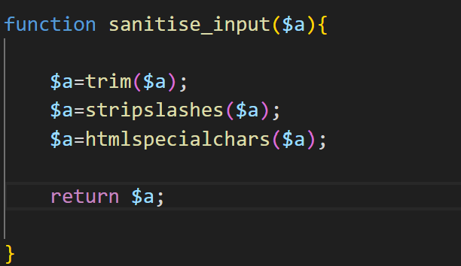

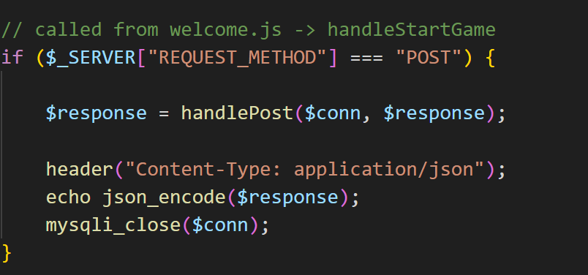

**Fig.17: Code snippet – sanitizing the input data Fig.18: Code snippet – Request Method check**

**Calculation of the User Score**

* A **FOR** loop was used to extract the correct answer for each question based on the ‘question Id’ and the ‘question type’.
* If ‘user answer’ was the same as the ‘correct answer’, player score was increased.
* At the end of the loop, the user score was calculated.

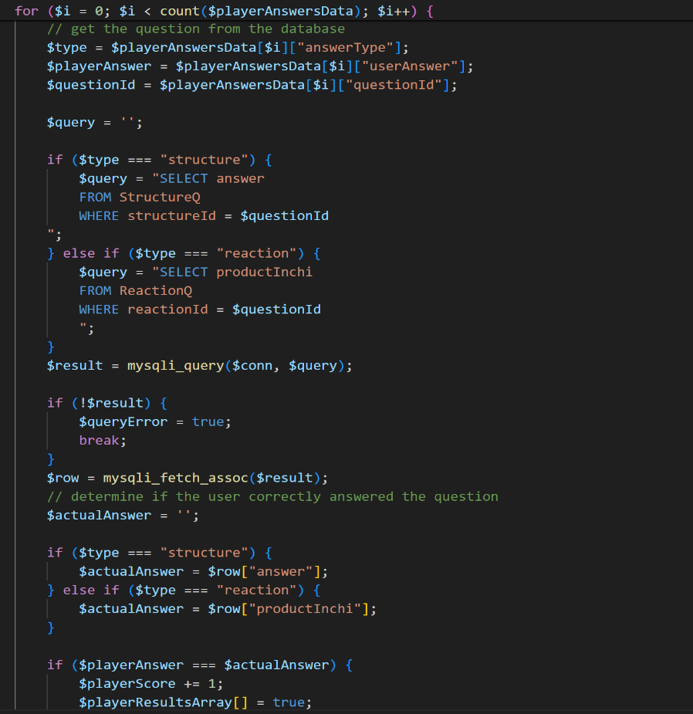

**Fig.19: Code snippet – Calculation of User Score**

**Updating User Scores to the Scores table**

* The calculated user score was updated to the Scores table by using an **INSERT** query to the Scores Table.

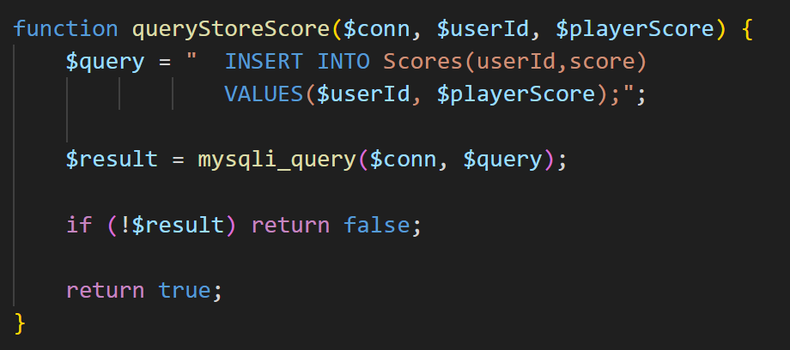

**Fig.20: Code snippet – Updating User Scores to the Scores Table**

**Extraction of the leaderboard Details**

* A **SELECT** query using **JOIN** and **GROUP BY** clauses was used extract the **TOP 5** performing students and their highest scores to display as a student leader Board.

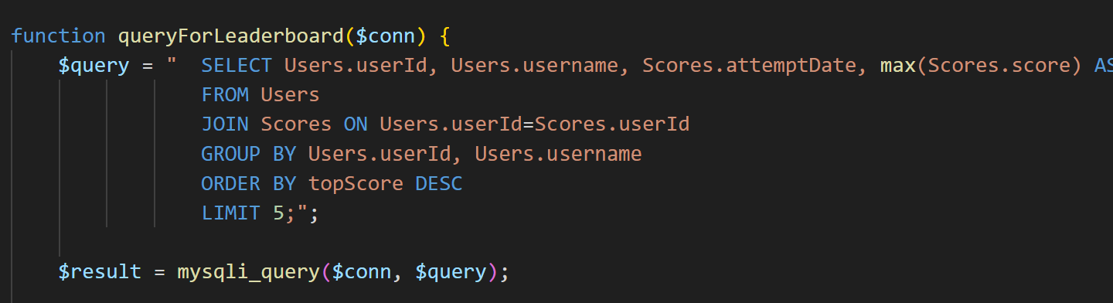

**Fig.21: Code snippet – Extraction of the leaderboard details**

**Extraction of the number of game attempts**

* A **SELECT** query with a **count (*)** was used to extract the number of attempts the specific user had played the quiz.

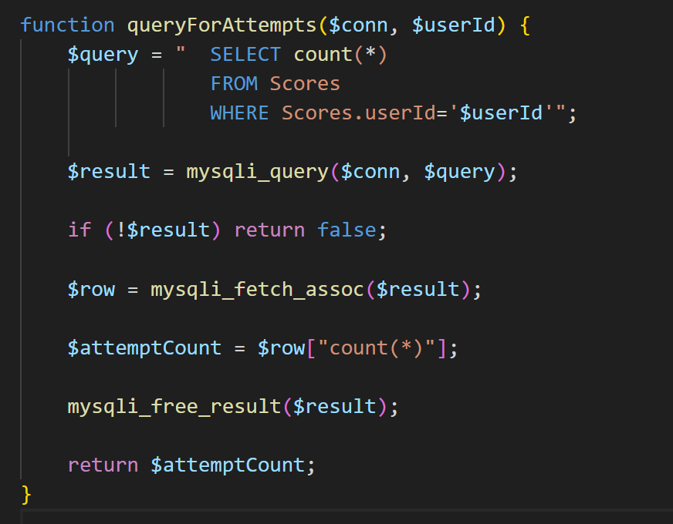

**Fig.22: Code snippet – finding the number of game attempts**

**Finding the results of the 5 most recent attempts of the student**

* A **SELECT** query with an **ORDER BY** and **LIMIT** clause was used to extract the 5 most recent results of the student arranged by date of latest attempt.

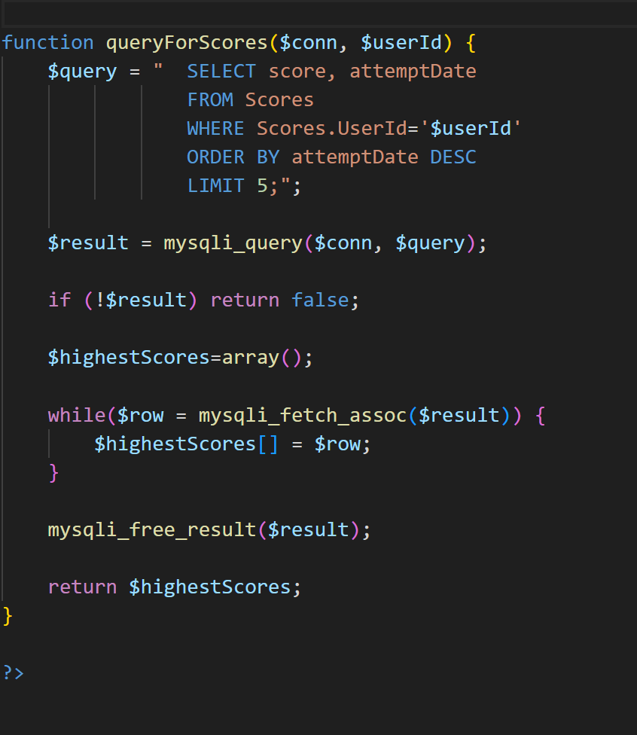

**Fig.23: Code snippet – finding the results of the 5 most recent attempts of the student**

**Returning the details to the question.js file**

Once all these details are calculated, the **Results.php** file returns these details as an array of objects to the question.js file. **(Smith,2015).**

* The questions.js stores the details in the session storage of the browser.

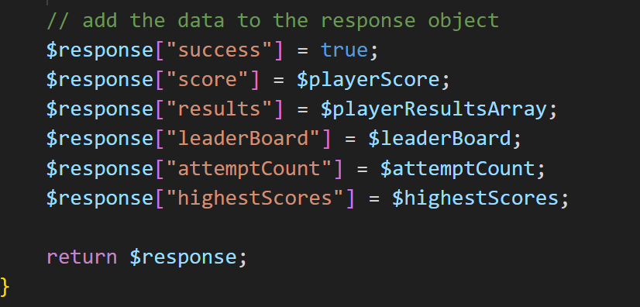

**Fig.24: Code snippet – returning the details as an array of objects back to the Question.js file**

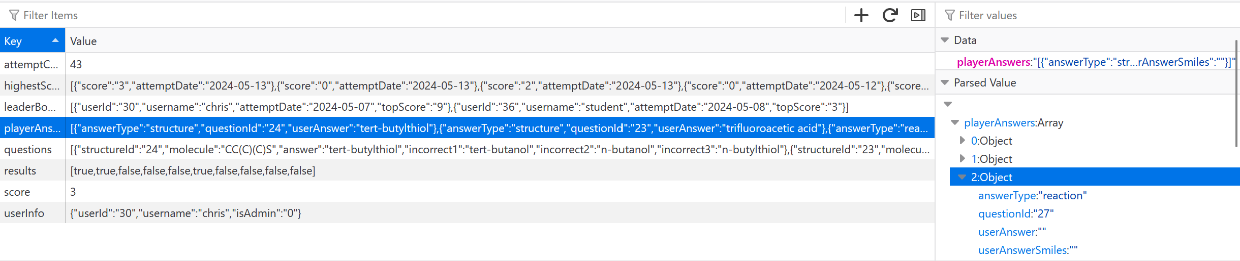

**Fig.25: Code snippet – the returned details are stored in session storage of the browser**



**Fig.26: Code snippet – data is stored as JSON – ‘key’:’value’ pairs**

**Rendering of the results on the Results page**

* The **results.js** takes up the data stored in the session storage, parses it and invokes a **renderPlayerResponses()** function to render each question , the user’s answer and the correct answer one by one.

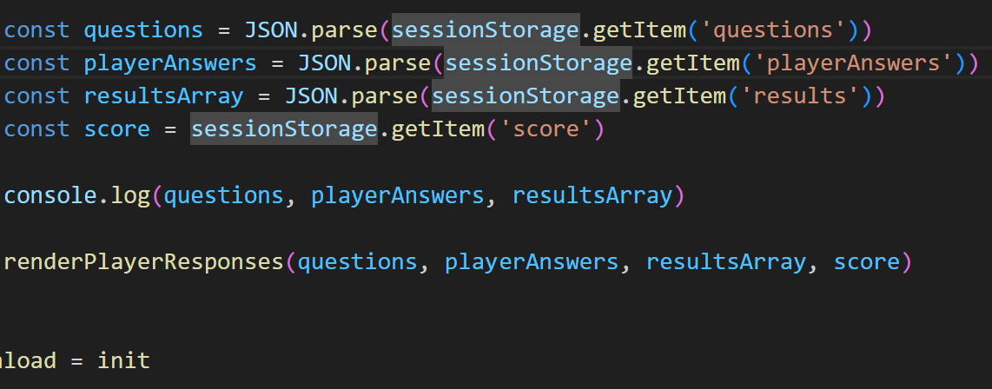

**Fig.27: Code snippet – data picked by results.js file**

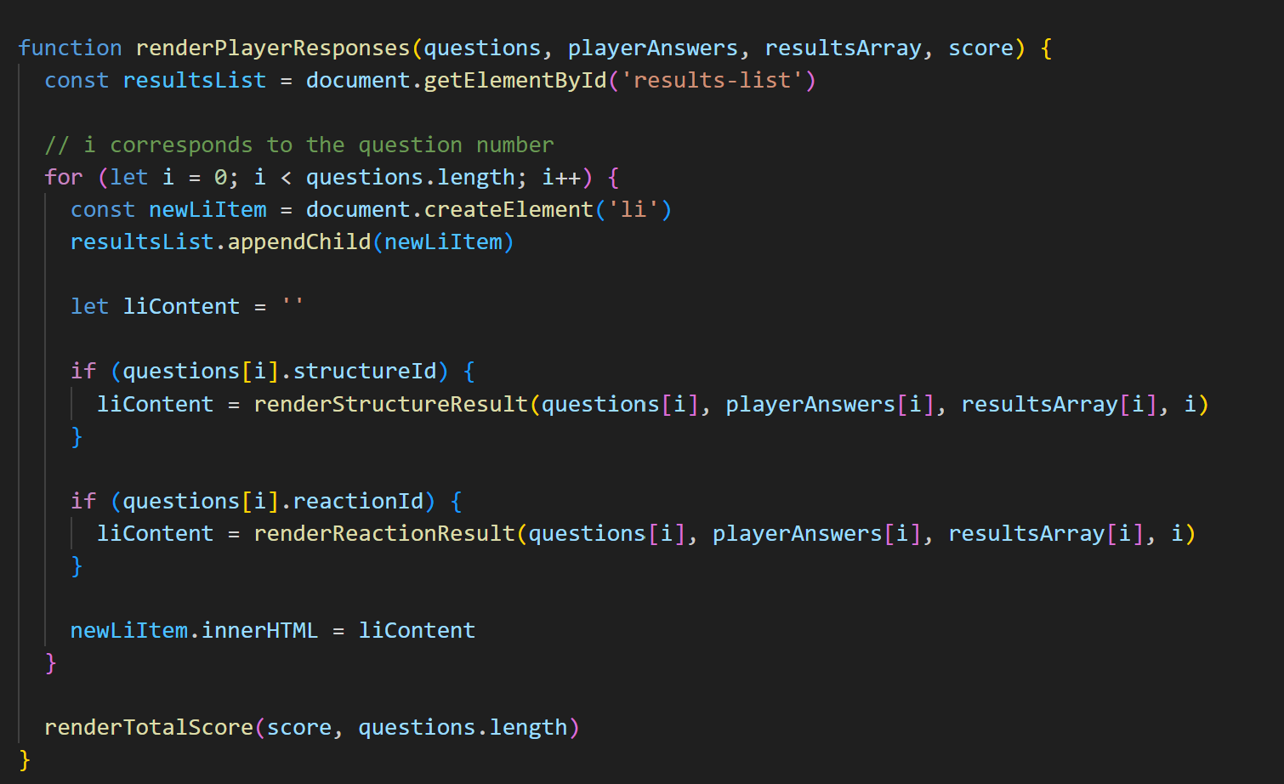

**Fig.28: Code snippet -function for rendering the results**

* The question type was checked whether it was ‘structure’ based or ‘reaction’ based and a corresponding function was called, which made use of an **Rdkit (JavaScript library)** to render the chemical structures on the screen as a ‘HTML template string’.

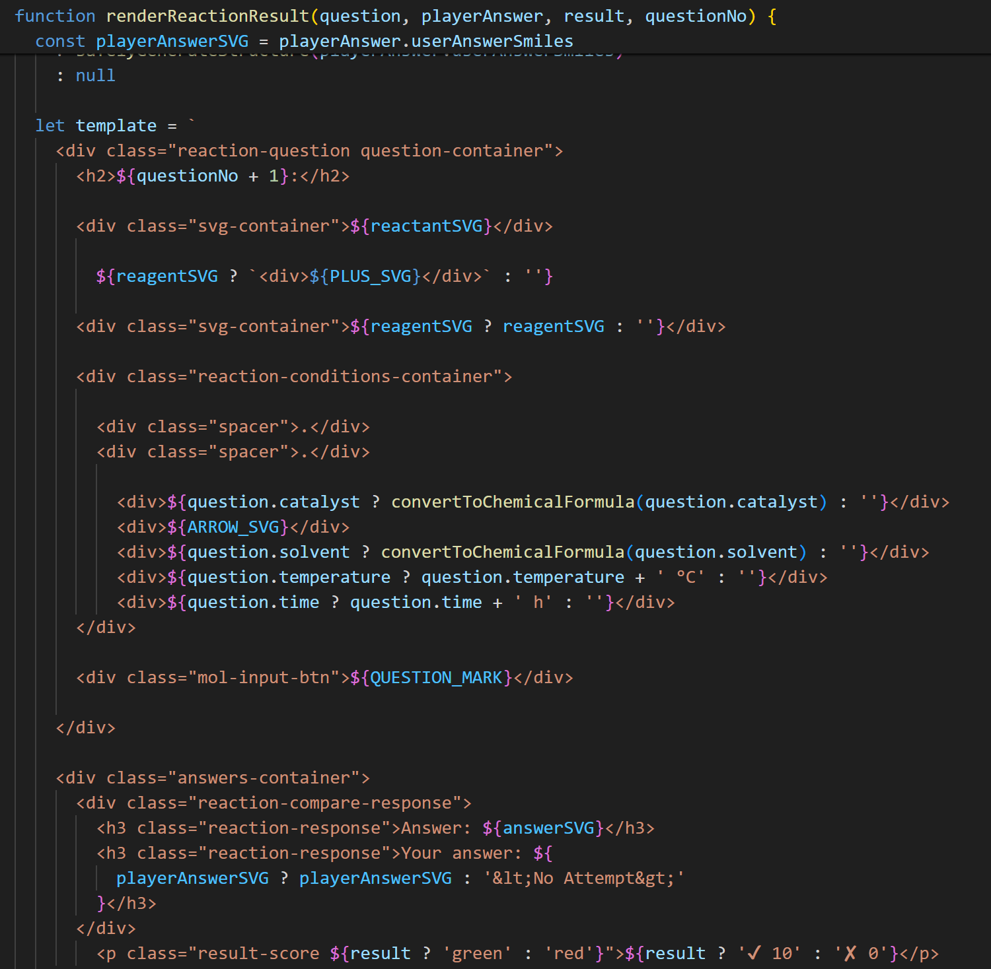

**Fig.29: Code snippet-the result rendered as a html template string from JavaScript**

**Display of the Student Score**

* Finally, a function was used to display the student score and a custom message was also displayed based on the score percentage achieved.

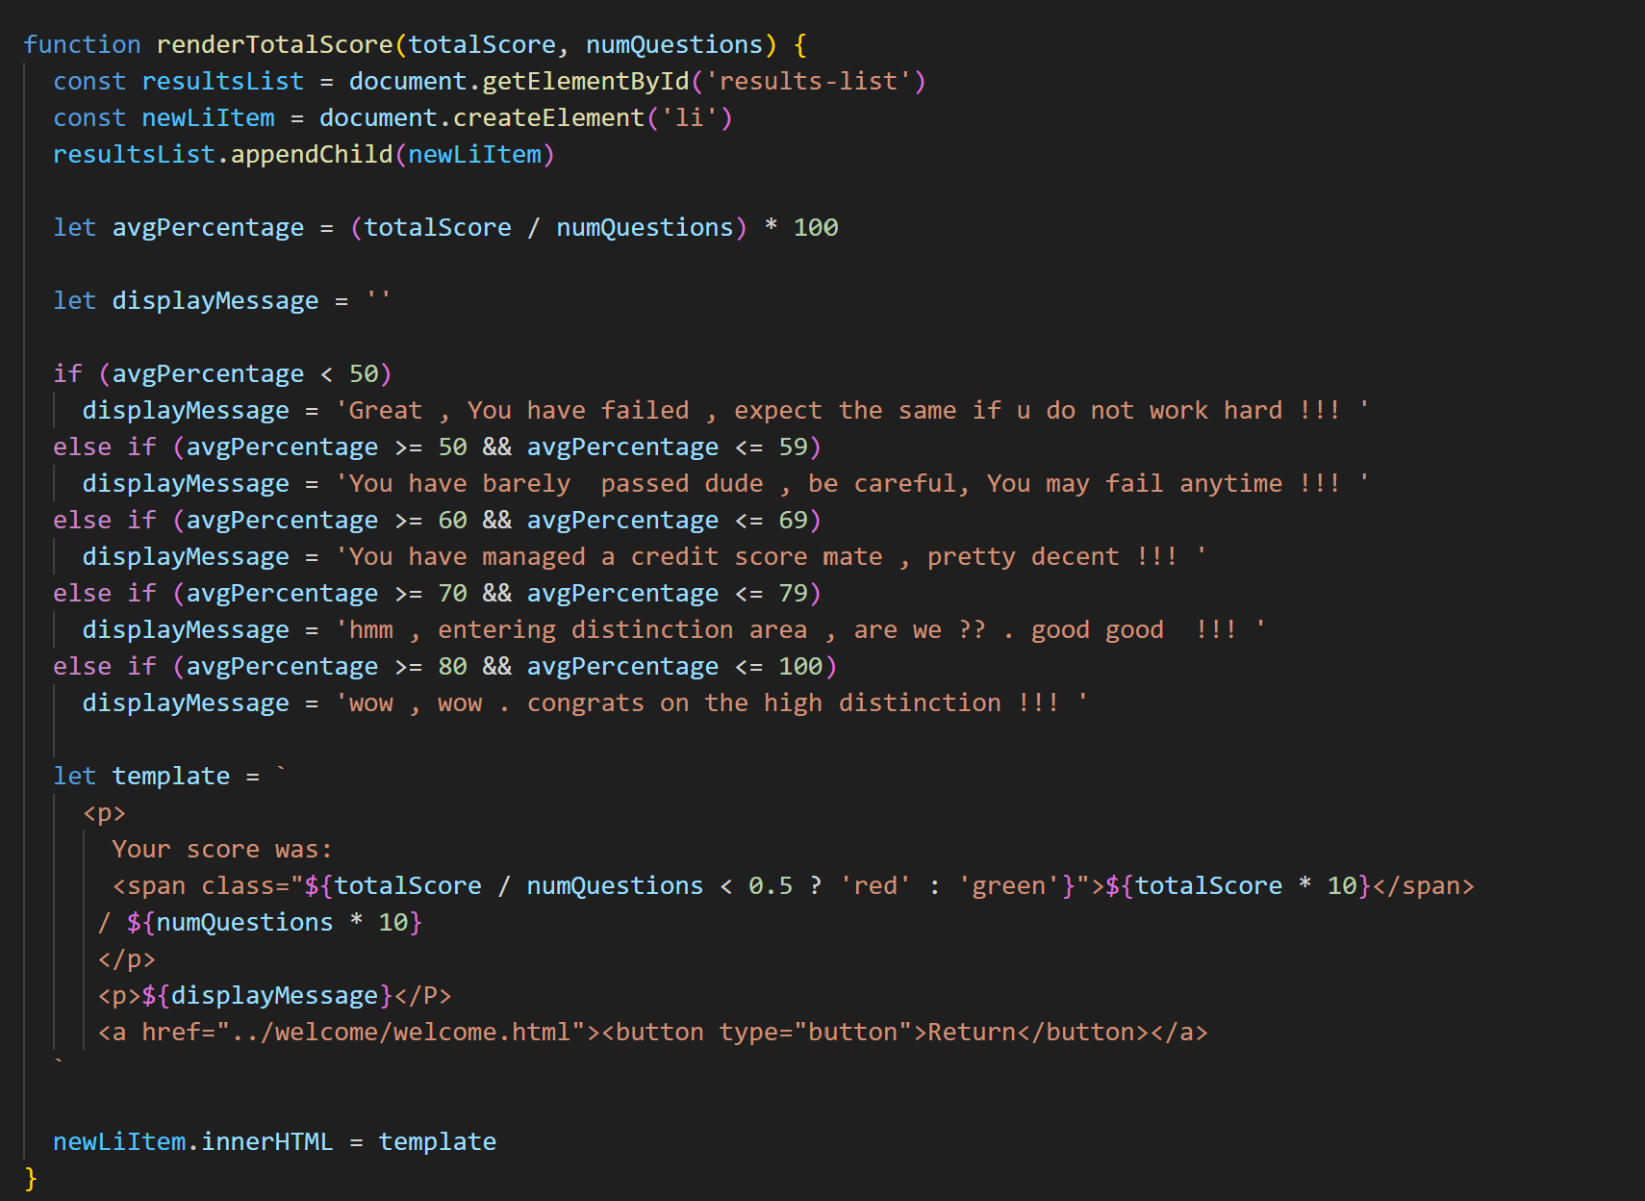

**Fig.30: Code snippet-to display the final student score and customer message based on the score**

**CSS page to design the results.html page**

* A CSS page was also implemented to style the UI of the results page to offer a neat and immersive usage experience.

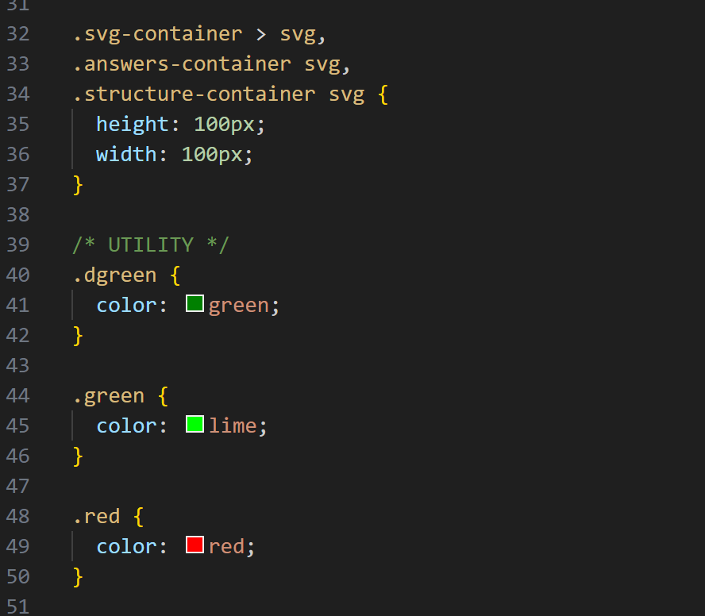

**Fig.31: Code snippet-results.css page to style the UI of the results page**

### 2.4.4 Display of Final Results and Student Feedback

The following things are displayed to the student for each of the question:

* The questions what was asked
* The student’s answer
* The actual Correct answer
* The student’s score out of 10 and a custom message based on the score obtained.
* The students’ answer is displayed in Green along with a tick mark, if his/her answer is correct.
* The students’ answer is displayed in Red along with a cross mark, if his/her answer is wrong.
* This offers the students instant feedback as well as the actual correct answers for them to compare and identify the mistakes they have made.

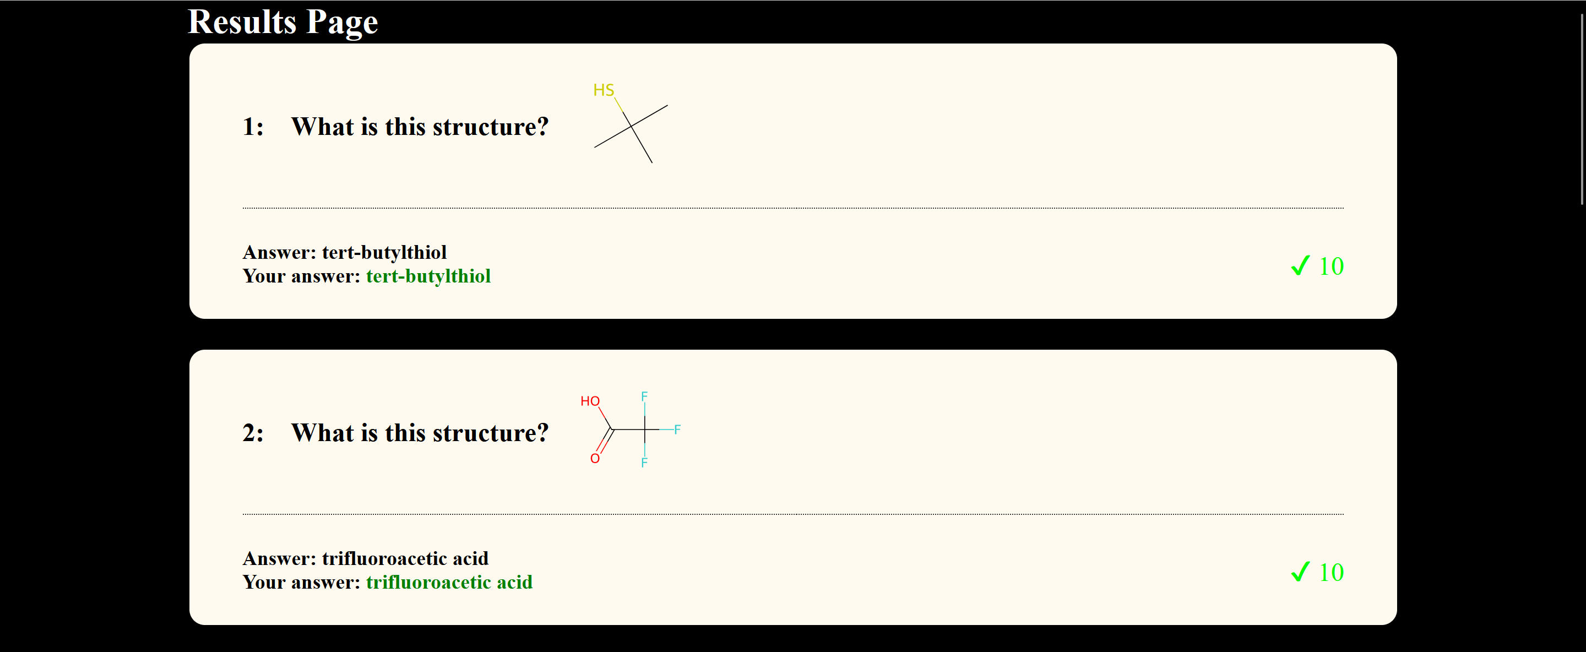

**Fig.32: Results page -1**

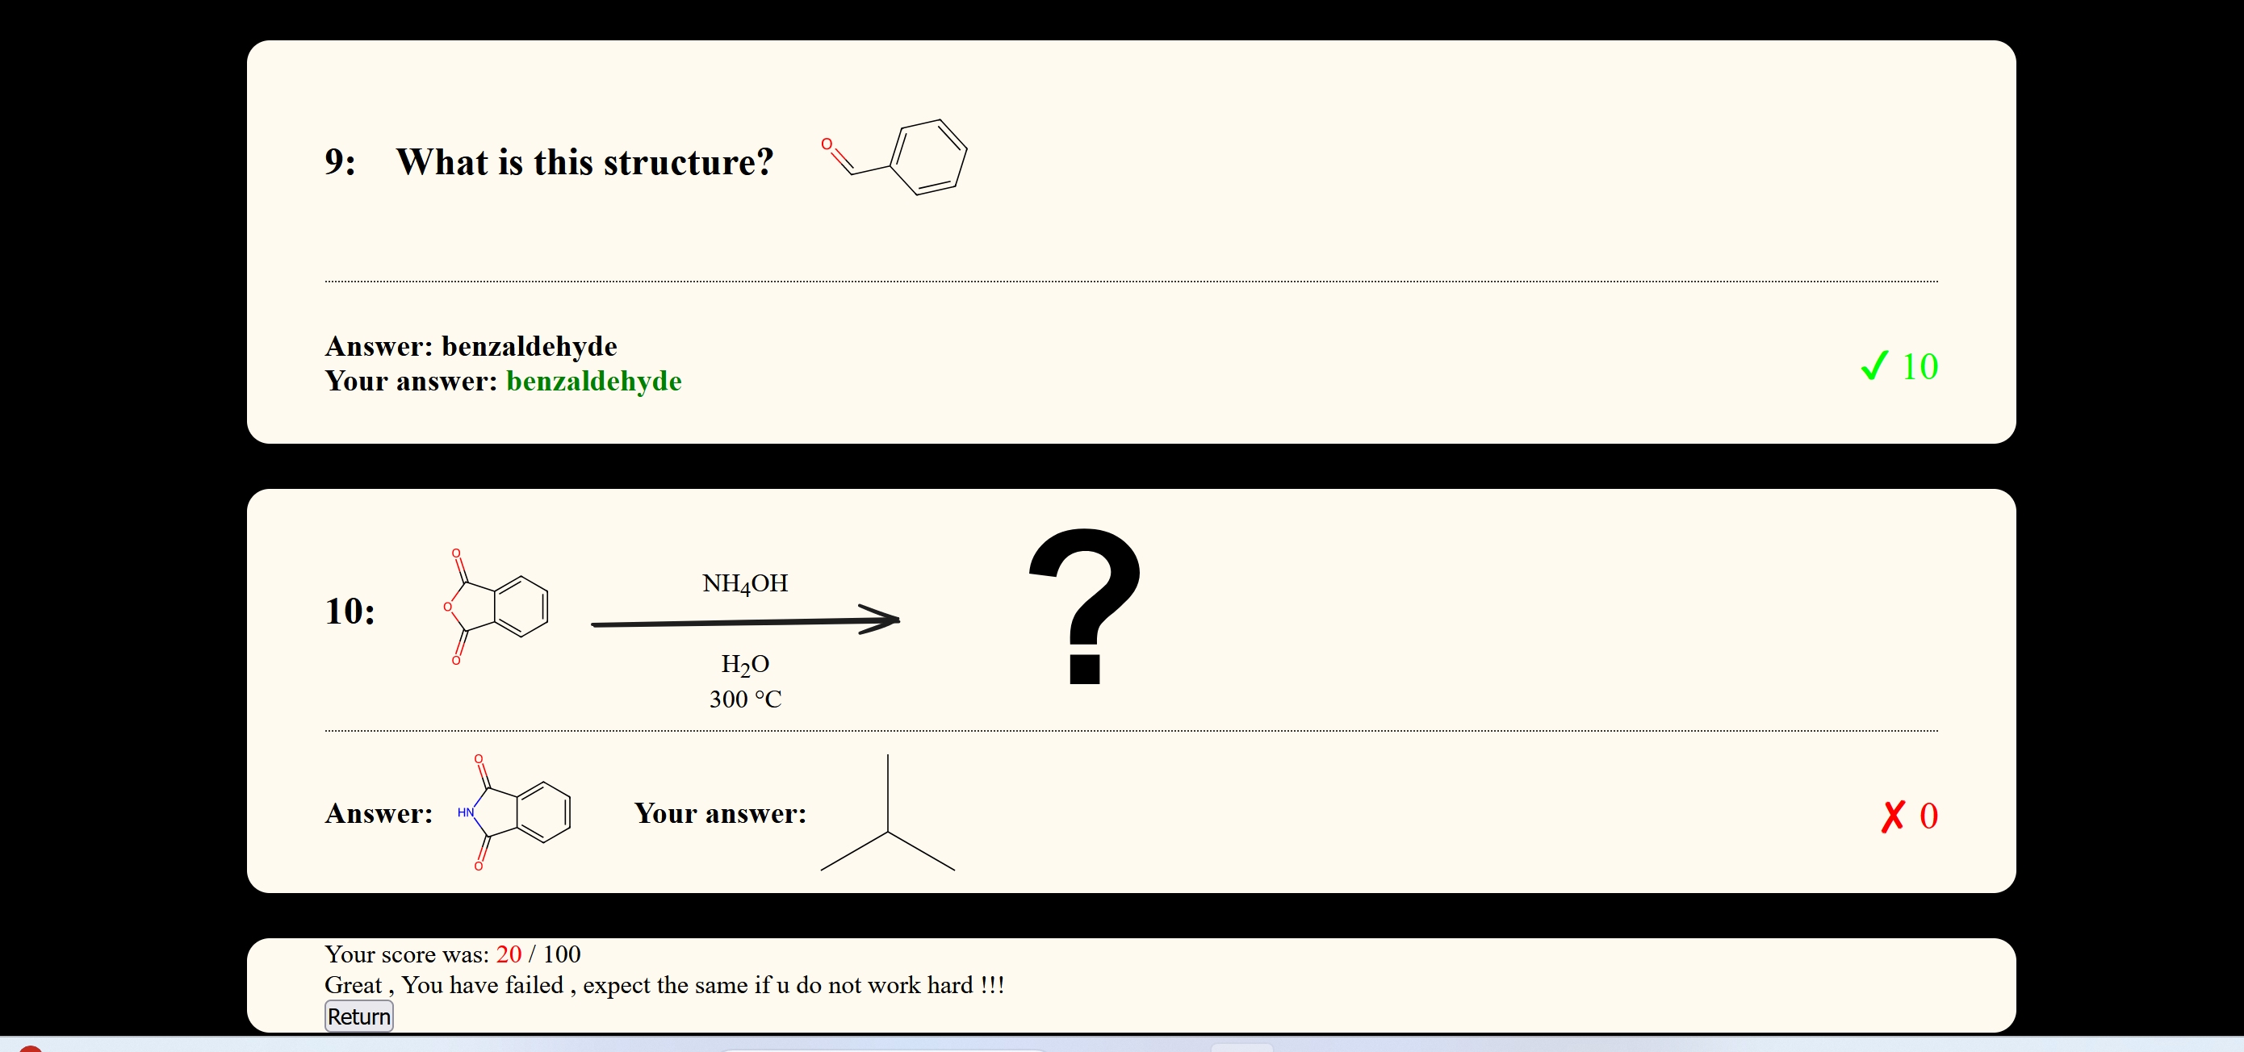

**Fig.33: Results page-2**

### 2.4.5 Leaderboard, game statistics and viewing peer performance

* When a student clicks on the **‘RETURN’** button on the results page, he /she is redirected to the Welcome page.
* An updated leaderboard and individual game statistics that was calculated is displayed here.
* The students can use this as a web discussion forum for doing self and peer evaluation.

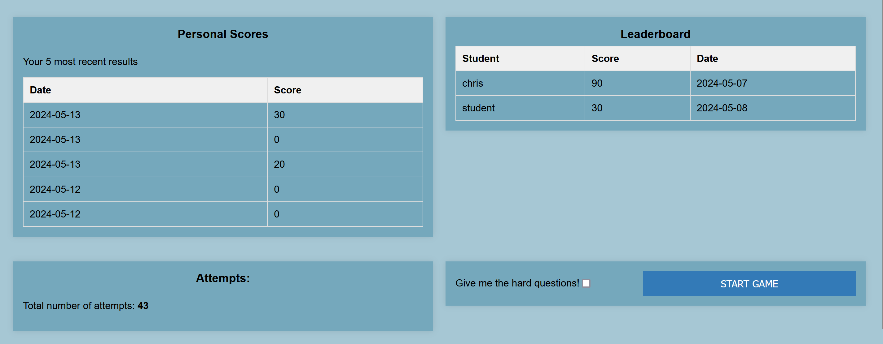

**Fig.34: Leaderboard and Game statistics**

## 2.5 Team Contributions:

* My individual contributions to the team were integral to the success of the project.
* Volunteered to lead, organize and manage the team in crucial situations to ensure that the project stayed on track and deadlines were met.
* Made important technical contributions, particularly in database design and backend logic, which were crucial in building a robust and secure application.

### 2.5.1 Team Engagement and Communication

* Throughout the project, active engagement and consistent communication with team members was maintained.
* Proactive participation in scheduling meetings as well as attending meetings was ensured.
* Contributions at meetings consisted of brainstorming new ideas and deeply analysing current ideas.

**Evidence:**

* Coordinated through chats and messages, discussing and sharing ideas.

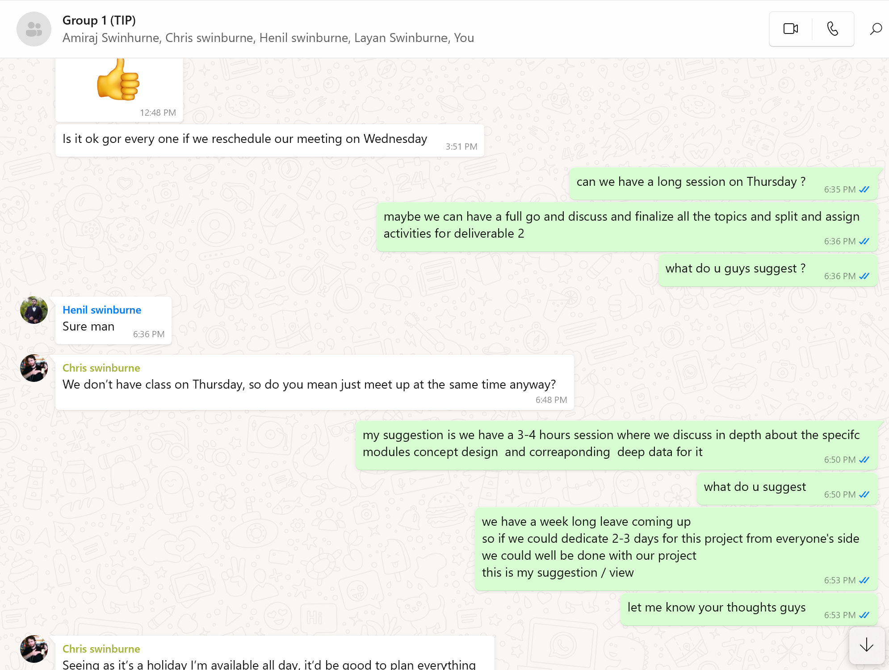

**Fig.35: WhatsApp chat discussions**

* Helped in Task allocations and implementations for team members.

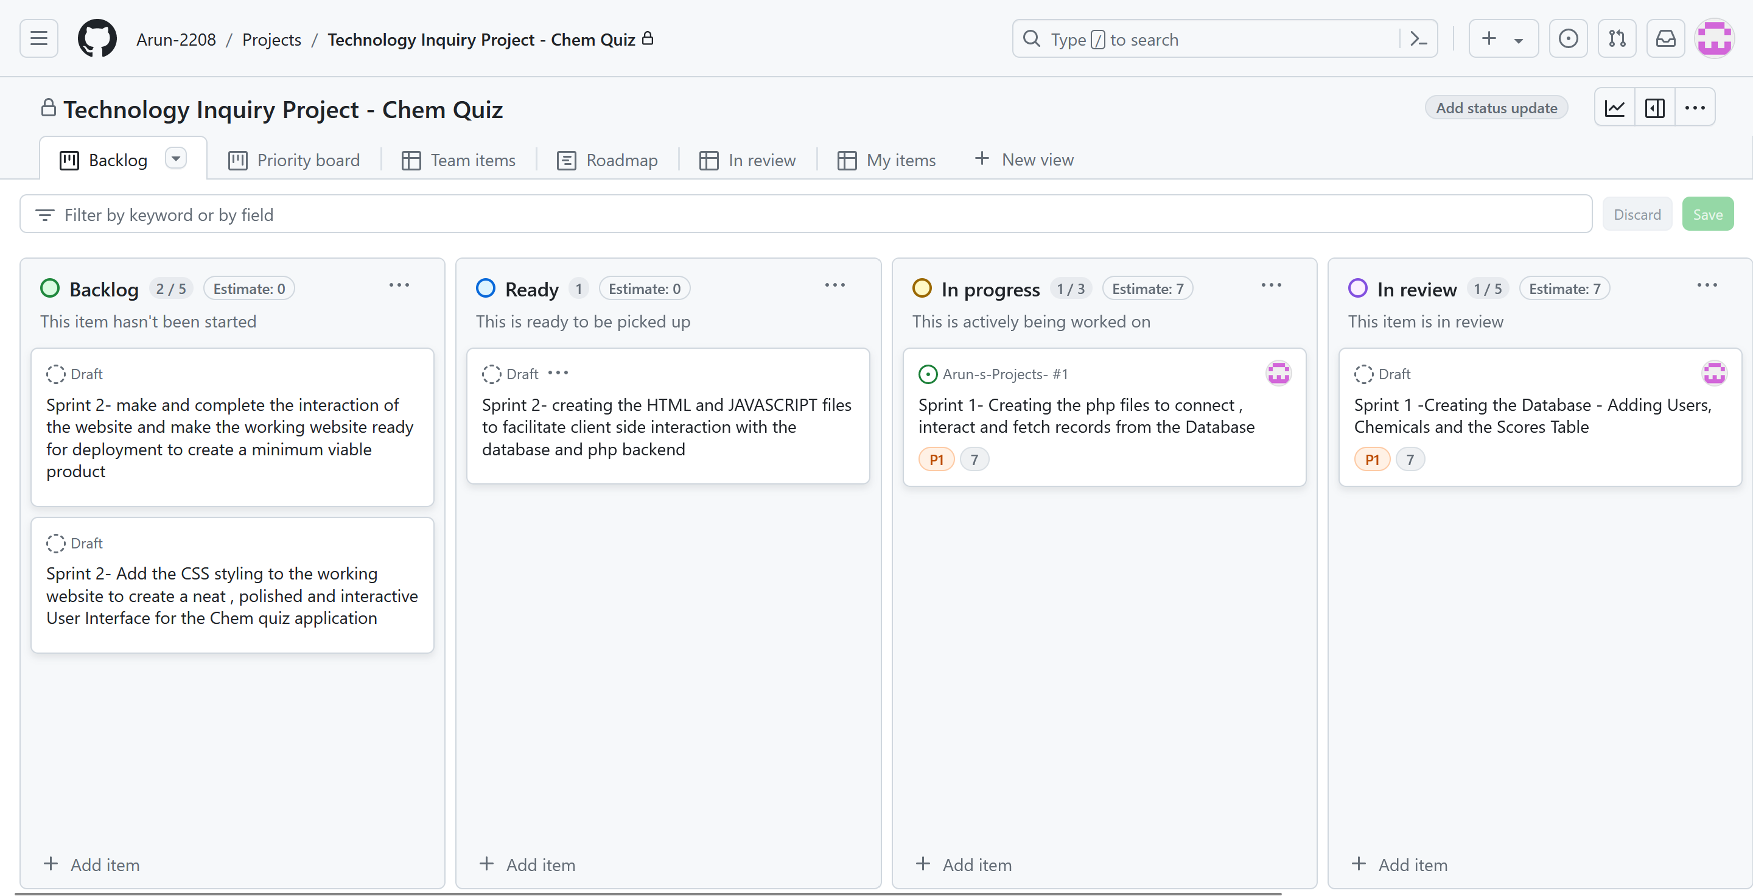

**Fig.36: Task splitting for sprints**

### 2.5.2 Taking Leadership of Team Activities

* Team leadership role was taken up enthusiastically at important situations.
* Key responsibility was taken for organizing and scheduling meetings, which included booking rooms and coordinating gathering times that worked for all members.
* A sincere effort was put into understanding everyone’s availability and communicating in a corresponding way, so that everyone could give their maximum participation.
* A Trello board was handled, to ensure proper assignment of task, meeting deadlines and delivery of the project on time.

**Evidence:**

* Coordinated and booked rooms for team meetings and discussions on project work. Provided sample templates and examples for team members to work on.

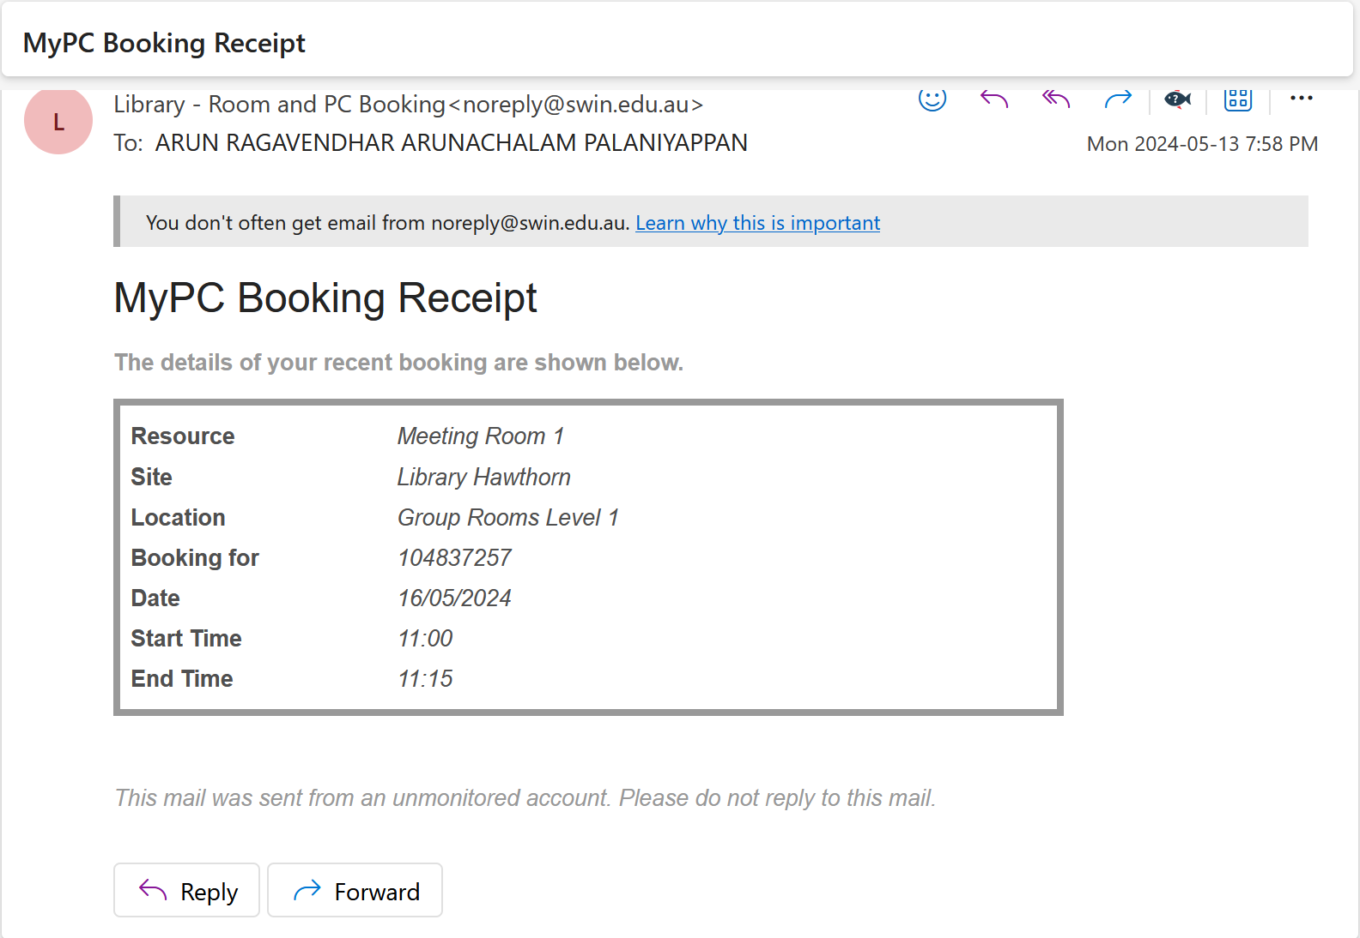

**Fig.37: Coordinating and booking a room for team meetings**

### 

**Fig.38: Providing sample templates for team members**

### 2.5.3 Technical Support and Collaboration

* Continued technical support and suggestions were provided to other team members on various aspects of the project.
* This included guidance on database design, backend logic, and frontend implementation.
* This collaborative approach helped ensure a high-quality and cohesive final product.

**Evidence:**

* Sharing technical documentation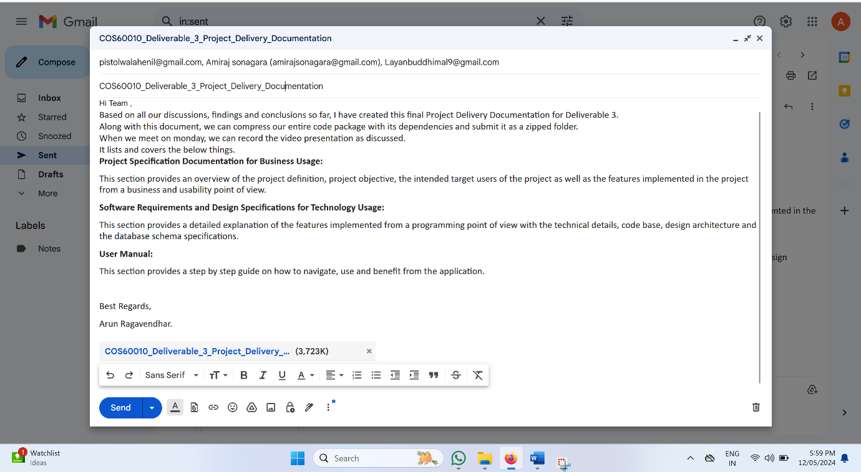, files and inputs through mail and canvas group.

**Fig.39: Team Project Documentation sent to team members through mail**



**Fig.40: Provided technical inputs for team members to work upon and uploaded the files on canvas**

# 3.Learning outcome Reflection

## 3.1 Role of programming fundamentals to identify and solve problems at various situations.

* The principles of modularity and abstraction were used by separating the project into backend (PHP scripts) and frontend (HTML, CSS, JavaScript) modules.
* This improved code maintainability and also allowed the clear separation of tasks for different team members, that is, each member was able to work on one specific module by focusing on the core logic without the need for dealing with other pieces of code.
* Principles of error handling were used to ensure the robustness of user interactions. An appropriate validation and error messages were added using **try and catch** blocks and **input data sanitisation** was donefor critical user interactions to prevent potential SQL injection vulnerabilities.

## 3.2 Reflection on using self and peer evaluation to enhance the individual work done.

* Continuous progress throughout the project was made possible via peer and self-evaluation.
* During team meetings, all members routinely discussed each other's work with active participation.
* Constructive peer review from team members proved helpful in identifying areas needing improvement, such as enhancing the user interface for easier accessibility or optimizing SQL queries for better performance of the results page.
* Peer input was crucial in improving the functionality of the PHP and the JavaScript pages, leading to well optimised display of quiz results.
* Another important factor was self-evaluation. An individual notebook was maintained to keep track of individual accomplishments and challenges related to design and coding.
* Prompt assistance and help was requested from colleagues and the facilitator whenever necessary.

## 3.3Application of advanced programming fundamentals to solve complex technology challenges in the project to overcome steep hurdles.

* One significant challenge that required a deeper understanding and usage of advanced programming concepts was the debugging of bugs and logical errors in the PHP script.
* PHP does not directly have a debugger console like JavaScript.
* Moreover, these types of error do not directly break the code, and hence do not directly show up when the program is run, but it changes the expected output, thereby leading to incorrect outputs.
* To overcome this issue, a **PHP debugger** was set up and installed to analyse and debug the PHP code line by line. **(Nixon,2021).**
* It was a steep learning curve, but a necessary one, and was eventually achieved.
* Additionally, the project required designing and optimizing complex database queries to handle dynamic content updates, such as real-time quiz score calculation, leaderboard updates and fetching updated user statistics.
* This challenge required a deeper understanding of SQL and database indexing and the usage of **SQL JOINS AND LIMIT** clause operations were learnt.

## 3.4 Usage of project management tools to effectively aid team collaboration.

* Effective teamwork was a highlight of this Chem Quiz project, and project management tools like Trello and GitHub played pivotal roles in facilitating collaboration.
* **Trello Board** was used to create and manage task boards, allowing the team to check the progress and manage workloads efficiently.
* Each task was assigned to a team member with clear deadlines and descriptions, which ensured accountability and timely completion.
* **GitHub** was crucial for version control, and enabled seamless collaboration on code through branches, commits, and pull requests.
* These tools not only streamlined communication and task management but also created a collaborative environment where each team member could contribute in a meaningful way.

## 3.5 Evaluation of information obtained from research on new technology and application of the new learnings in the project.

* Research played a critical role in the successful delivery of this Chem Quiz project.
* The process began with identifying the most suitable technology stack, for which extensive Individual research work was done on various web development frameworks and databases.
* Sources such as academic papers, online tutorials, and documentations were referred and evaluated. All referred documents have been duly cited in the report.
* At the end, since it was a web-based project – PHP and JavaScript were decided to be used as the main scripting languages as they are most suitable for web development and have a neat syntax as well as a logical and easily understandable code flow. **(Andrew et al., 2003).**
* Organizing this information through detailed notes and reference documents ensured that it could be quickly referred back when needed.

## **3.6 Influence of Cultural and Social perspective on the learnings, Individual work done and the outcome of the project.**

* The Chem Quiz project provided an opportunity to reflect on the impact of social and cultural perspectives on team dynamics and project outcomes.
* Working in a diverse team, we encountered varying viewpoints and communication styles, which initially posed challenges but ultimately enriched our collaborative efforts as all team members soon learnt to respect and accept every other member’s view point and understanding when it comes to differences.
* Understanding and respecting these differences led to more inclusive decision-making processes and created a supportive environment.
* For example, scheduling meetings at times that accommodated all team members and their available hours and being mindful of cultural holidays helped maintain team bonding.
* This awareness of social and cultural factors not only improved teamwork but also ensured that our project was designed with a broader audience in mind, enhancing its accessibility and relevance in today’s world.

# 5.Summary

In this report, a detailed account of my individual contributions to the "Chem Quiz" project developed for Instatute Learning Pty.Ltd for their high school students, has been provided and backed up with accurate and suitable evidences for support.

My Individual Contribution consisted of several key areas, including project objectives and user requirement gathering, individual research, design contributions, code contributions, and team contributions. In the design phase, the individual contribution that was made proved to be instrumental in creating the database schema, entity-relationship diagrams, the results page and the overall system architecture.

My individual code contributions included development of essential components such as the results page, user score calculations, and leaderboard functionality. Evidence of my work was provided through code snippets, GitHub commit history, and relevant screenshots.

A major individual contribution was done towards team activities like maintaining active engagement and communication within the team, taking on leadership responsibilities, and providing technical support and collaboration to ensure the project's success.

An effective reflection on the learning outcomes was also done on how the basic and advanced programming techniques were utilized and applied, self and peer evaluation practice used and the efficient usage of project management tools along with the learnings relating to social and cultural perspectives of all team members of the project.

Overall, this report illustrates the meaningful, comprehensive and high-quality Individual contributions that was made to the "Chem Quiz" project, demonstrating the ability to work effectively as an individual and as part of a team to deliver a successful and fully functional web-based application.

# 6.Appendix

## 6.1 Abbreviations

**DB**: Database

**UI:** User Interface

**HTML**: Hypertext Markup Language

**CSS**: Cascading Style sheets

**JSON**: JavaScript Object Notation

**PHP**: Hypertext Preprocessor

**SQL**: Structured Query Language

## 6.1 List of figures and tables:

**Table 1:** Relational DB schema with sample record of Users table.

**Table 2:** Relational DB schema with sample record of Scores table.

**Figure.1:** Entity-Relation Diagram of Users and Scored Table

**Figure.2:** Control flow of the system for the results page

**Figure.3:** A Sample sketch for the results page User Interface

**Figure.4:** Evidence Screenshot-1 for System design Contributions

**Figure.5:** Evidence Screenshot-2 for System design Contributions

**Figure.6:** Evidence Screenshot-3 for System design Contributions

**Figure.7:** Evidence Screenshot-4 for System design Contributions

**Figure.8:** Evidence Screenshot-5 for System design Contributions

**Figure.9:** Evidence Screenshot-6 for System design Contributions

**Figure.10:** Trello Board listing out the Individual Tasks

**Figure.11:** Ghantt Chart listing out the step by step weekly Individual Task

**Figure.12:** Evidence Screenshot for database creation

**Figure.13**: Evidence Screenshot for tables creation

**Figure.14:** Code snippet – Data base connection-setup

**Figure.15:** Code snippet – Data base connection-query

**Figure.16:** Code snippet – getting the player answers

**Figure.17:** Code snippet – sanitizing the input data

**Figure.18:** Code snippet – Request Method check

**Figure.19:** Code snippet – Calculation of User Score

**Figure.20:** Code snippet – Updating User Scores to the Scores Table

**Figure.21:** Code snippet – Extraction of the leaderboard details

**Figure.22:** Code snippet – finding the number of game attempts

**Figure.23:** Code snippet – finding the results of the 5 most recent attempts of the student

**Figure.24:** Code snippet – returning the details as an array of objects back to the Question.js file

**Figure.25:** Code snippet – the returned details are stored in session storage of the browser

**Figure.26:** Code snippet – data is stored as JSON – ‘key’:’value’ pairs

**Figure.27:** Code snippet – data picked by in results.js file

**Figure.28:** Code snippet-function for rendering the results-1

**Figure.29:** Code snippet-the result is rendered as a html template string from JavaScript

**Figure.30:** Code snippet-to display the final student score and customer message based on the score

**Figure.31:** Code snippet-results.css page to style the UI of the results page

**Figure.32:** Results page -1

**Figure.33:** Results page-2

**Figure.34:** Leaderboard and Game statistics

**Figure.35:** Team Project Documentation sent to team members through mail

**Figure.35:** WhatsApp chat discussions

**Figure.36:** Task splitting for sprints

**Figure.37:** Coordinating and booking a room for team meetings

**Figure.38:** Providing sample templates for team members

**Figure.39:** Team Project Documentation sent to team members through mail

**Figure.40:** Provided technical inputs for team members to work upon and uploaded the files on canvas

# 7. References

Andrew, R., Ullman, C., & Waters, C. (**2003**). Fundamental Web Design and Development Skills. *Glasshouse*.

Bienfait, B., Ertl, P. J. Cheminformatics, L. (**2013**). JSME: a free molecule editor in JavaScript. *SpringerNature*.

Delisle, M. (**2006**). Creating Your MySQL Database. *Packt Publishing Ltd*.

Full, M. (**2020**). How the Internet Works and the Web Development Process. *Independently Published*.

Gehani, N. (**2011**). The Database Application Book Using the MySQL Database System. *Apress Media, Llc*.

Landrum, G. (**2013**). RDKit.js. https://www.rdkitjs.com/

Nixon, R. (**2021**). Learning PHP, MySQL, and JavaScript. *O’Reilly Media, Inc*.

Prettyman, S. (**2020**). Learn PHP 8: using MySQL, JavaScript, CSS3, and HTML5. *Apress Media, Llc.*

Simpson, J. (**2023**). How JavaScript Works. *Apress Media Llc*.

Smith, B. (**2015**). Beginning JSON: [learn the preferred data format of the web]. *Apress Media, Llc*.